**Salesforce Project Implementation Phases**

**Phase 3: Data Modeling & Relationships**

In this phase, I design the Salesforce data model for the Telemedicine Access for Rural Healthcare project. Proper data modeling ensures that all stakeholders (patients, doctors, pharmacy staff, and health officers) can interact with the system smoothly while maintaining security and scalability.

* **Standard & Custom Objects**

I used both standard Salesforce objects and custom objects.

**Standard Objects Used:**

- User → Doctors, Admins, Pharmacy Staff.

- Contact → Patients (extended with custom fields).

- Account → Civil Hospital / Clinics.

**Custom Objects Created**:

- Appointment__c – Stores teleconsultation appointment details.

- Prescription__c – Holds doctor-issued prescriptions.

- Medicine_Inventory__c – Tracks stock availability at local pharmacies.

- Symptom_Checker__c – Logs AI-based symptom assessments.

- Notification_Log__c – Tracks reminders, SMS, and alerts.

* **Fields**

Each custom object includes key fields to capture project requirements.

**Appointment__c**

- Patient (Lookup → Contact)

- Doctor (Lookup → User)

- Date/Time (DateTime)

- Status (Picklist: Scheduled, Completed, Cancelled, No-Show)

- Mode (Picklist: Video, In-person)

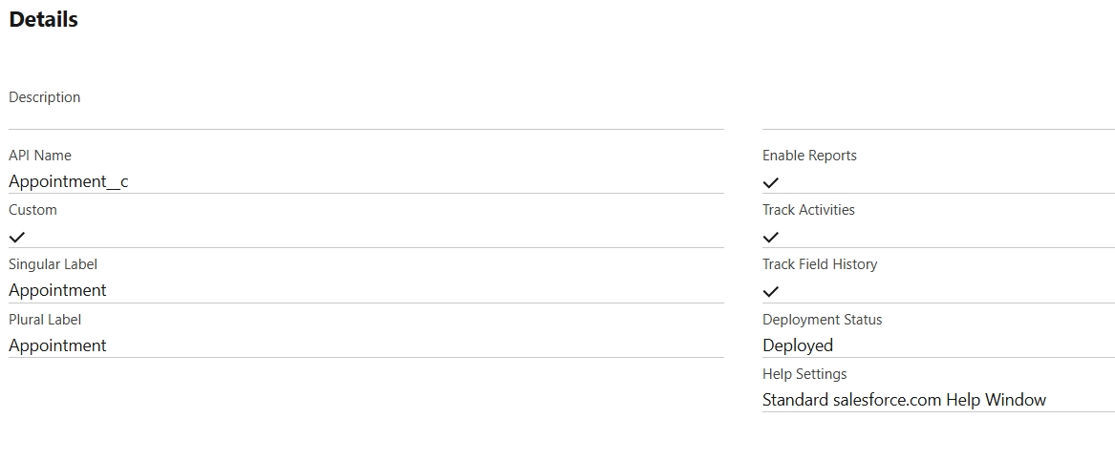

**Prescription__c**

- Appointment (Lookup → Appointment__c)

- Doctor Notes (Long Text)

- Medicine List (Text Area)

- Next Review Date (Date)

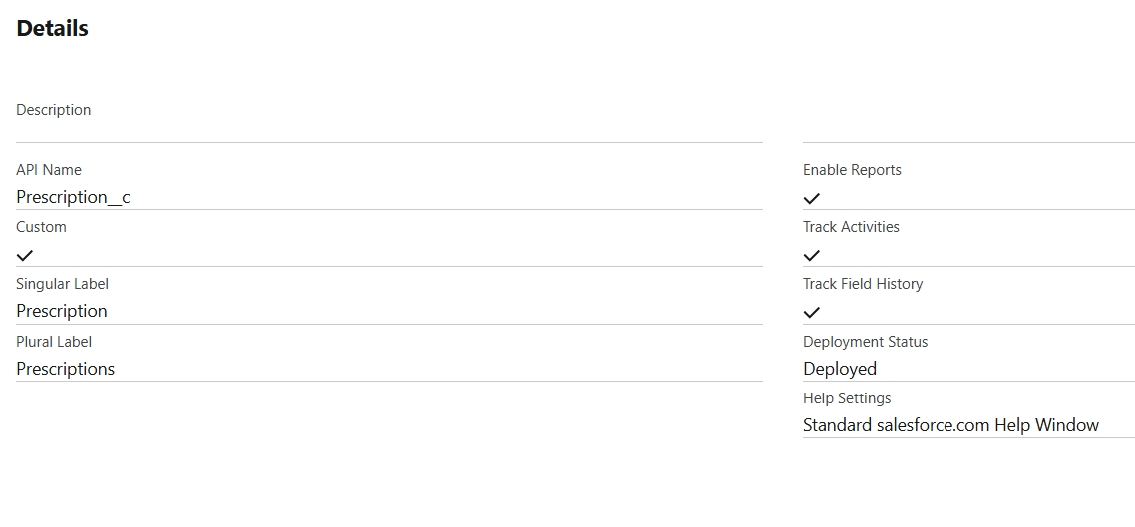

**Medicine_Inventory__c**

- Medicine Name (Text)

- Stock Quantity (Number)

- Expiry Date (Date)

- Pharmacy Location (Text)

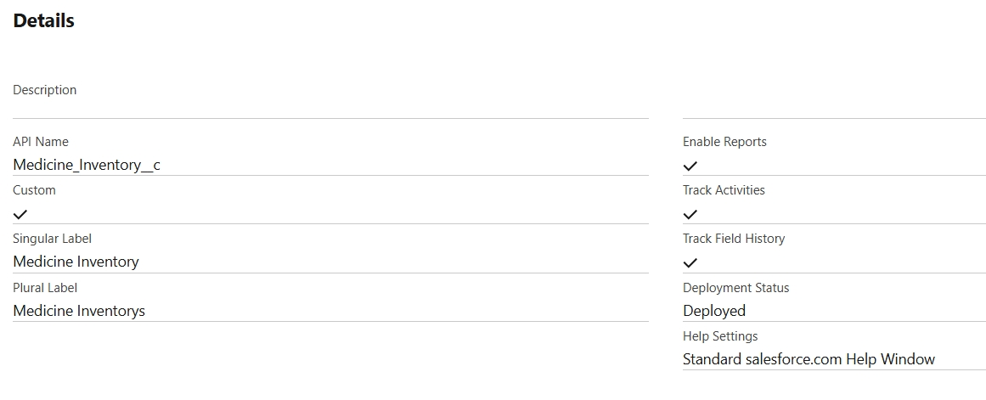

**Symptom_Checker__c**

- Patient (Lookup → Contact)

- Entered Symptoms (Text Area)

- Suggested Action (Picklist: Home Care, Doctor Visit, Emergency)

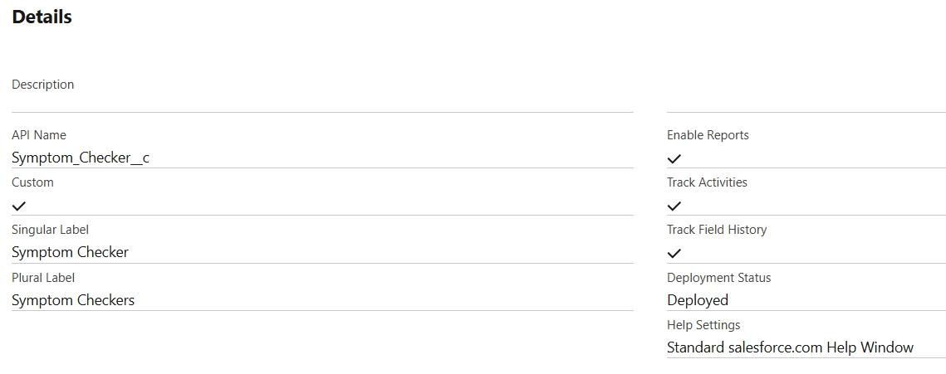

**Notification_Log__c**

- Patient (Lookup → Contact)

- Type (Picklist: SMS, WhatsApp, Email)

- Message Content (Long Text)

- Status (Picklist: Sent, Failed, Pending)

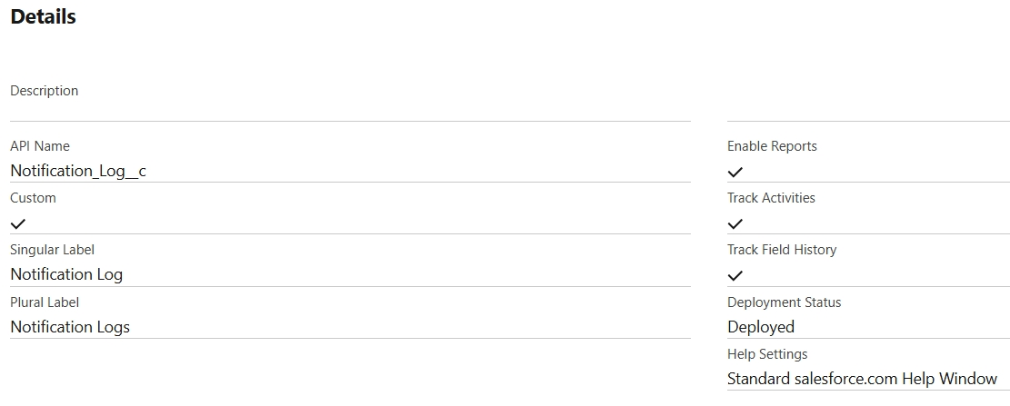

**Prescription_Medicine__c**

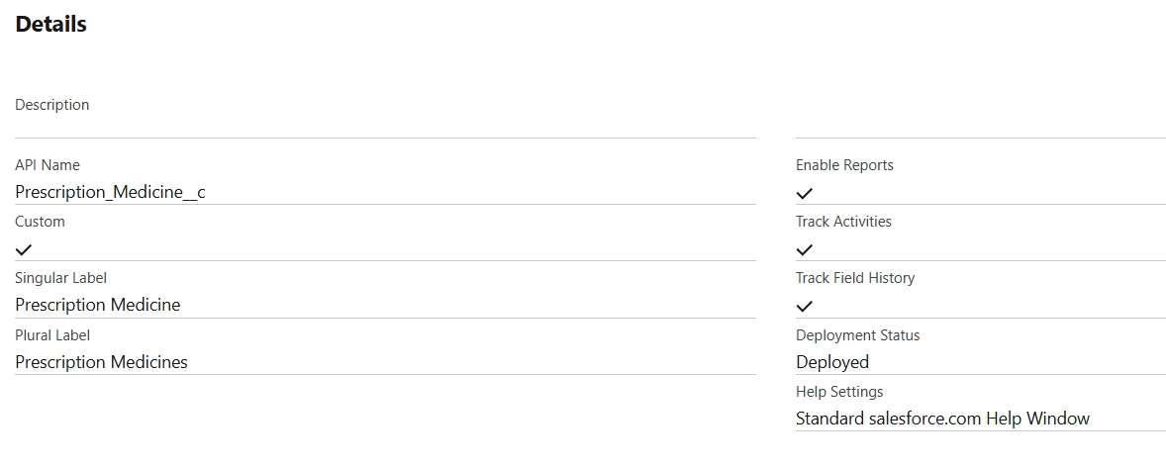

* **Record Types**

I used record types to manage different processes within the same object.

**Appointment__c Record Types:**

- General Consultation

- Specialist Consultation

- Follow-Up

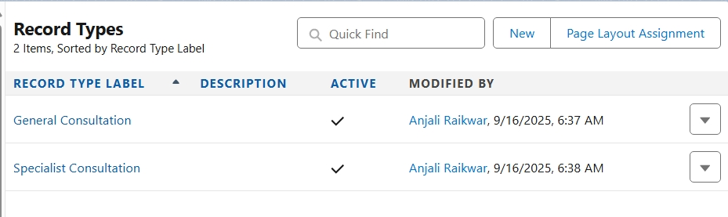

**Prescription__c Record Types:**

- Regular Prescription

- Emergency Prescription

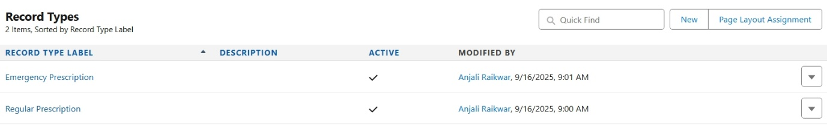

This allows customized page layouts and business processes.

* **Page Layouts**

I created different layouts for different users:

- Doctor Layout (Appointment): Shows patient details, symptoms, prescription fields.

- Pharmacy Layout (Medicine): Shows medicine name, stock, expiry.

- Patient Layout (Community): Only summary fields visible (doctor, date, notes).

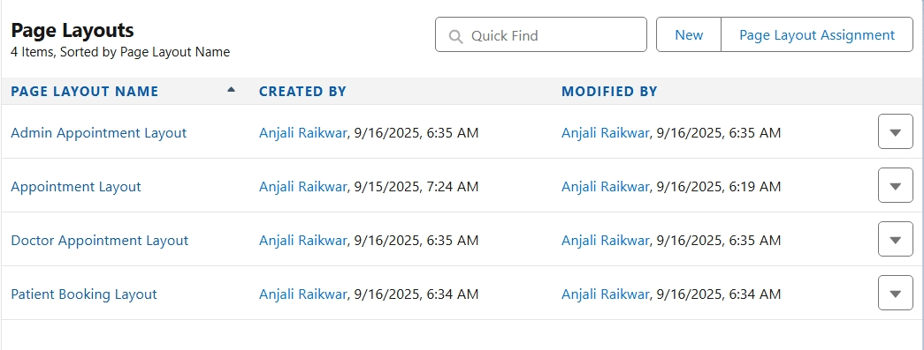

* **Compact Layouts**

Compact layouts improve mobile/Lightning view.

**1. Appointment Compact Layout:**

- Patient

- Doctor

- Date/Time

- Status

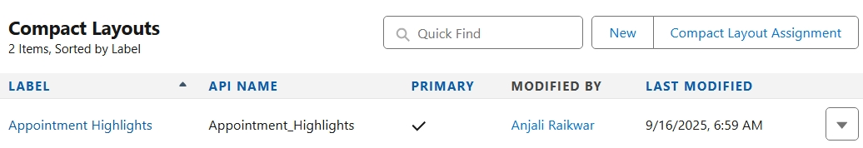

**2. Medicine Inventory Compact Layout:**

- Medicine Name

- Stock Quantity

- Expiry Date

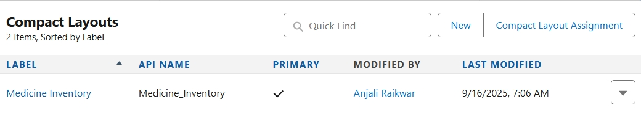

* **Schema Builder**

I used “Schema Builder” in Salesforce to:

- Visualize relationships between objects.

- Drag and drop new fields.

- Ensure field-level security for Patients vs Doctors.

**Schema Snapshot:**

- Contact → Appointment__c (Lookup)

- User → Appointment__c (Lookup)

- Appointment__c → Prescription__c (Master-Detail)

- Appointment__c → Notification_Log__c (Lookup)

- Medicine_Inventory__c → Prescription__c (Junction for many-to-many)

* **Lookup vs Master-Detail vs Hierarchical Relationships**

**Lookup:**

- Appointment__c → Patient (Contact)

- Appointment__c → Doctor (User)

**Master-Detail:**

- Prescription__c → Appointment__c (if Appointment is deleted, prescription also deleted).

**Hierarchical:**

- Only for Users (not used in our model, but Admin can be superior to Staff).

* **Junction Objects**

I created a “ Prescription_Medicine__c (Junction Object) ” to handle many-to-many between Prescription and Medicine_Inventory.

**Fields:**

- Prescription (Master-Detail → Prescription__c)

- Medicine (Master-Detail → Medicine_Inventory__c)

- Dosage (Text)

- Duration (Number of Days)

This ensures a single prescription can include multiple medicines, and one medicine can belong to multiple prescriptions.

* **External Objects**

To integrate with “ Government Health Databases ” or “ Pharmacy ERP systems ”, we define “ External Objects.”

**Examples:**

- Govt_Health_Stats__x → External object for village-level healthcare reports.

- Pharma_Supplier_Inventory__x → External object to fetch stock availability from pharmacy ERP.

These external objects use Salesforce Connect (OData) to avoid data duplication).

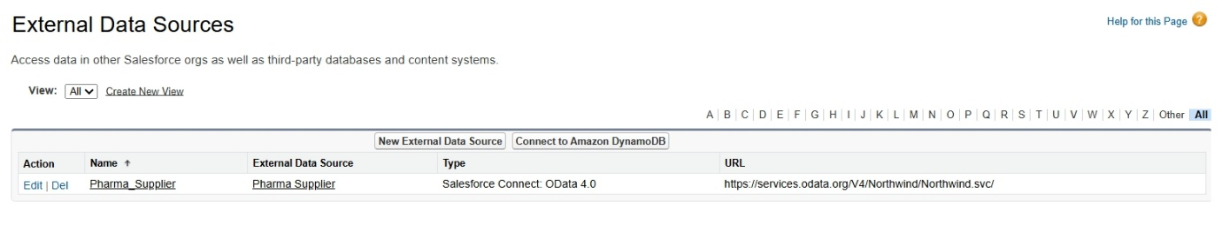

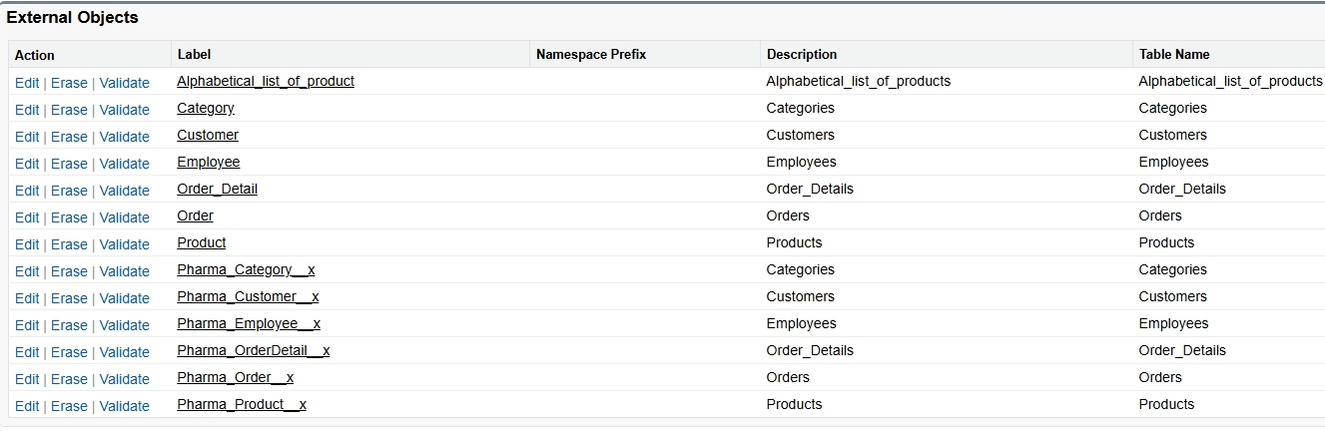

**Field-Level Security (FLS)**

Even if a field exists, not everyone should see it (privacy).  
Example: Aadhaar Number should only be visible to Doctors and Admin, not to Pharmacy Staff.

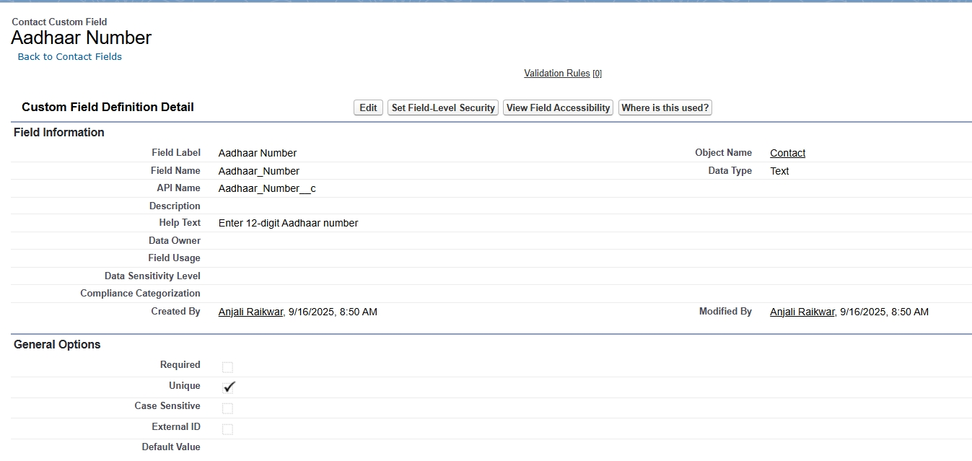

**Visible** for only:

* Doctor Profile
* System Administrator Profile

Now, only doctors and admins can see Aadhaar, others can’t.

**Outcome of Phase 3**

- Standard & Custom objects defined for Telemedicine use case.

- Record types, page layouts, and compact layouts implemented for role-specific UI.

- Relationships established (Lookup, Master-Detail, Junction Objects).

- Schema visualized using Schema Builder.

- External objects planned for ERP/Govt integrations.

With Phase 3 complete, our Salesforce org now has a Solid Data Foundation for building LWC components, automation, and analytics.